- Purpose
  - The purpose of this document is to describe the procedure for assembling an Optima Propane Burnisher motor pulley.
- Scope
  - This SOP applies to all equipment assembly team members. The process applies to the following machines:
E012800EQM0600BE1200 – 21” Optima XR
E012830EQM0600BE1200 – 27” Optima XR
E012840EQM0600BE1200 – 27” Optima XR w/ Emissions
E012850EQM0600BE1200 – 27” Optima XR w/ Dust Control
E012865EQM0600BE1200 – 27” Optima XR w/ Emissions & Dust Control
- Responsibilities
  - The operations manager/supervisor is responsible for enforcing the SOP.
- Materials
  - The proper materials needed for this process are listed on the machine work order.
  - Hand/Power Tools
- Definitions

- Procedure
  - Assemble the drive pulley assembly. This consists of a pulley (12546) and a bushing (12547). Three bolts and lock washers should be supplied with the bushing. Insert the bushing into the pulley and line the holes up. The pulley and bushing are tapered so they will only assemble one way. Attach the two pieces with the bolts and washers. Finger tight is all that is needed at this point.
Pulley
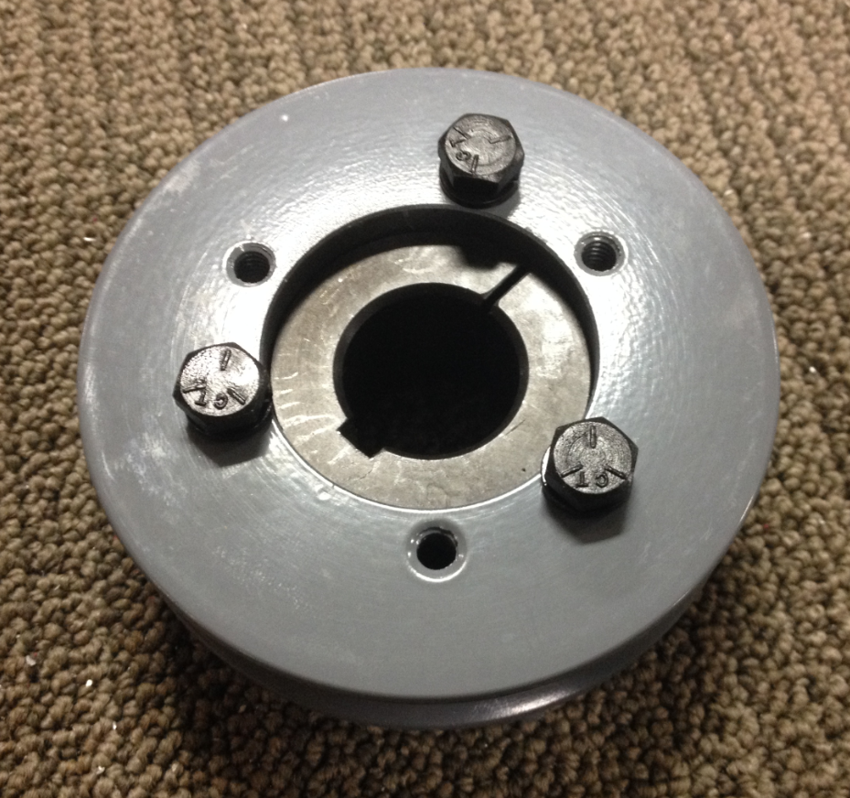
Bushing

- References (optional section as needed)

- Training Guide

Functional Training Groups Requiring Training
Equipment Assembly Group

- SOP Change Control

Date of Change | Reason for Change
Rev 01 - 11/22/2013 | This is the first version of the S.O.P. hence there are no revisions to this document.
Rev 02 - 1/12/2018 | Added Responsibilities Section
Rev 03 - 5/4/2018 | Updated for the Optima XR upgrades
Rev 04 - 3/21/2025 | Removed work center notes and updated machine ID’s in Scope 2.01

Approvals

Submitter/Author Approval:__________________________________ Date:______________________

Management Approval:______________________________________ Date:______________________

QAU Approval:_____________________________________________ Date:______________________

